

**COMP9900 – 2019 T2**

**Computer Science Project Report**

**Accommodation Web Portal**

**Group: Peppa pig**

Scrum Master: Chengzhu Xie z5140121@ad.unsw.edu.au

Developers: Jianyu Yi z5169682@ad.unsw.edu.au

Developers: Hao An z5138496@ad.unsw.edu.au

Developers: Luyao Zhang z5151973@ad.unsw.edu.au

# **CONTENT**

## Introduction

## Background

### 2.1 Market demand

### 2.2 Drawback of existing accommodation web and APP

### 2.3 Explore a New Application

## Web Features & Software Implementation

### 3.1 Home Page

### 3.2 Sign up

### 3.3 Sign in / Sign out

### 3.4 Search

### 3.5 Booking an order / Order System

### 3.6 write a review

### 3.7 Relevant Recommendation & Event Search

### 3.8 Message with host

### 3.9 Robot chatbot

## Software Architecture

## Conclusion

### 4.1 Challenge of Implementation & Solution

## Maintenance & Operation

## References

## **1．Introduction**

This report includes three parts. First part analyzing accommodation web portal market demand and the drawback of existing accommodation web portal. Second part demonstrating our web portal functions and software implementation. Third part is conclusion and how to maintain it.

Accommodation Web Portal is a Web application that will allow providers to present their holiday units, and users to review the offers and reserve or rent a property. The application is limited to properties located in NSW.

## **2．Background**

### **2.1 Market demand**

In statistics, 9.2 million international visitors to Australia in 2018. There is a big market in Australia. There was a total of 4.2 million international visitors to New South Wales in the 2017 calendar year. The total spend in New South Wales was $10.4 billion which accounted for 25% of all dollars spent in Australia for the year. From these statistics, we can find NSW is the biggest market in Australia. Due to this market, supporting tourism becomes quite potential and have big profit to dig. Additionally, accommodation is a big part of the spend.

When it comes to a trip, there are many aspects you need to consider. How do you get the destination? How long does it take? Where do you live temporarily? People need to choose transportation and book accommodation. In all these parts we need to consider, accommodation is the most important part because a trip is wonderful but tiring. Good rest will make sure visitors perfectly enjoy their trip. Nowadays, there are many accommodation websites providing a booking service due to the boost in internet development, such as Airbnb.com, Booking.com and so on. Airbnb has grown in popularity in recent years as part of a broader trend towards the ‘sharing economy’, where peer to peer platforms directly connect customers and providers. Hosts across Australia accommodated around 2.1 million guests for 3.7 million nights in 2015-16. Accommodation booking has a huge potential and still have more valuable functions can be achieved.

### **2.2 Disadvantage of Existing accommodation web and APP**

However, most part of customers may not have any information about their destination, book online becomes a good choice. Existing APP and websites like Airbnb, tripping, booking, just offer accommodation information and others like TripAdvisor, Yelp, only offer great restaurants or guidance trip information. This makes inefficient for customers. So, one APP that could merge these two resources and efficient show recommended restaurants and event information while customers looking for an accommodation is urgent to be produced.

Another problem with existing website is that they are totally great for the users who are already familiar with the pattern of utilization, those customers can easily find what they want. But for new customer, there are barely instructor and not friendly.

### **2.3 Explore a New Application**

For our team, we plan to create a web application that service for people who aim to travel in New South Wales. The main customers we focus on are the people who plan a trip for a few days in New South Wales and do not have any idea or know a litter bit about it. Not only this APP has all the functions that existing APP and website has, but it will have some very new and useful functions that cover the black of the accommodation market. For example, recommended restaurants and events around their destination will be shown on the accommodation page.

To solve the problem that existing websites not very friendly to new customers, we implement a chatbot in the web application. This chatbot will collect as many questions as possible, such as how to sign up, how to order, how to cancel an order, how to contact with host and so on.

The left part is that our websites needs to provide access for both customers and clients which want to be a landlord. And provide a booking function.

## **3. Web Features & Software Implementation**

**

### **3.1 Home Page**

* At home page, customer can sign up / sign in or do some search directly. As blow graph show, customer can search by some optional information like destination, guest number, check in time/check out time.
* Home page also has information about our company.

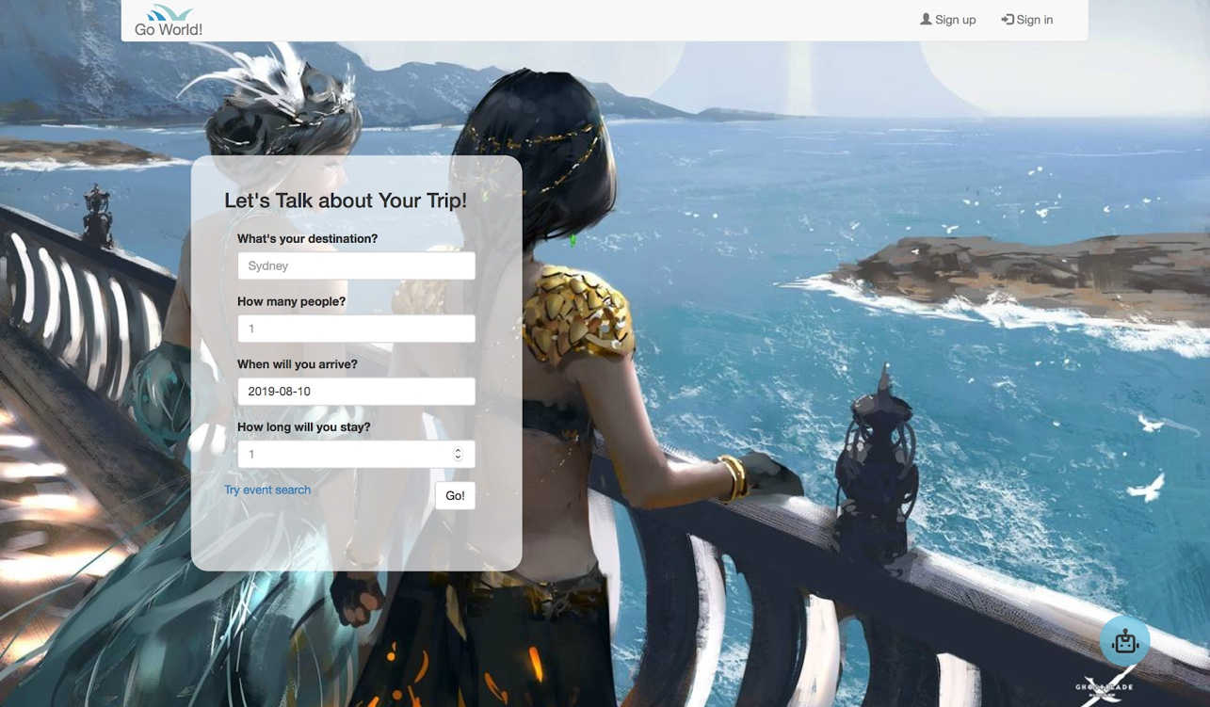

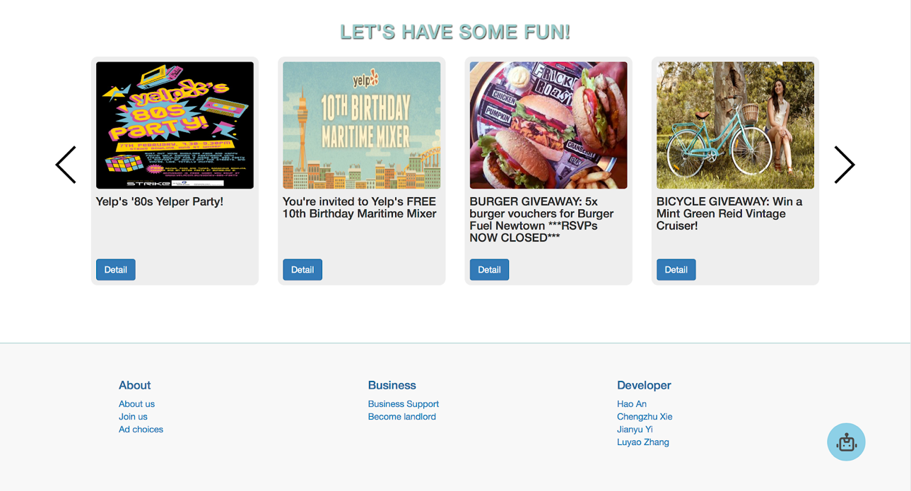

### **3.2 Sign up**

* For sign up function, sign up page will show like blow picture. Customer should fill up some personal information like *Account Name*, *Password* etc.
* This function is a very important part for user friendly websites. Website need has new customer to save their data in the database, which is convenient for administrator to manage.
* For users, they can easily book or managing their order or property when they have their account.

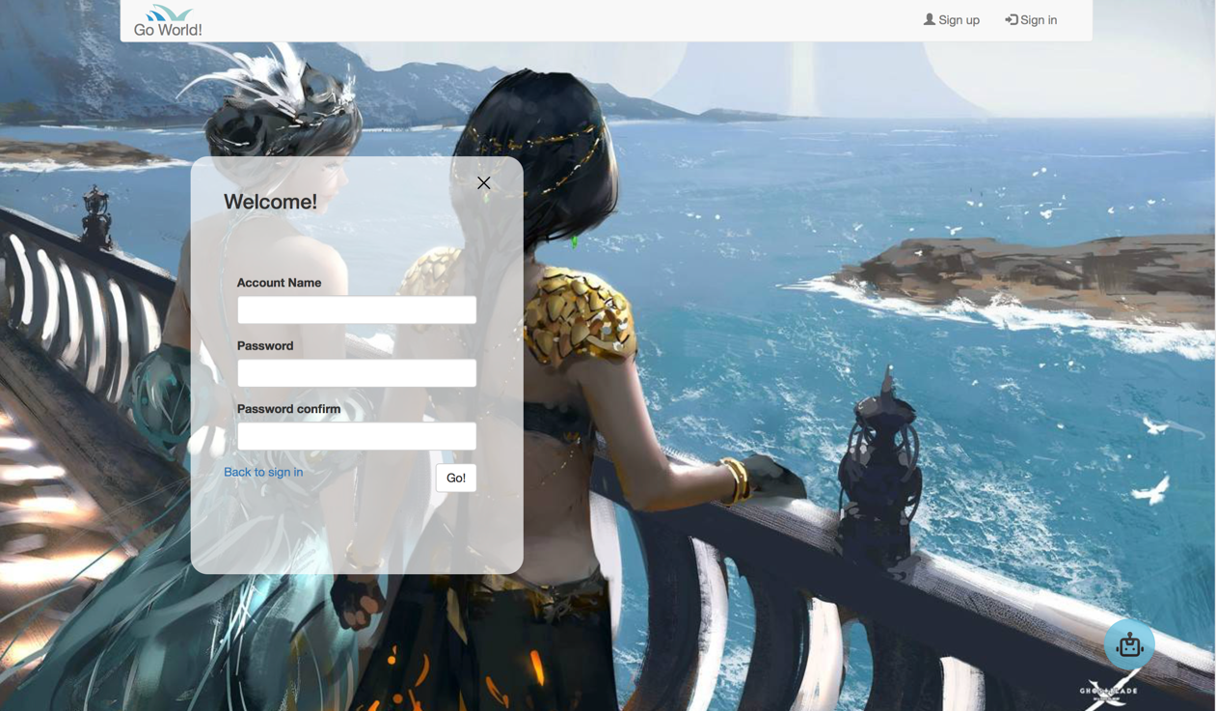

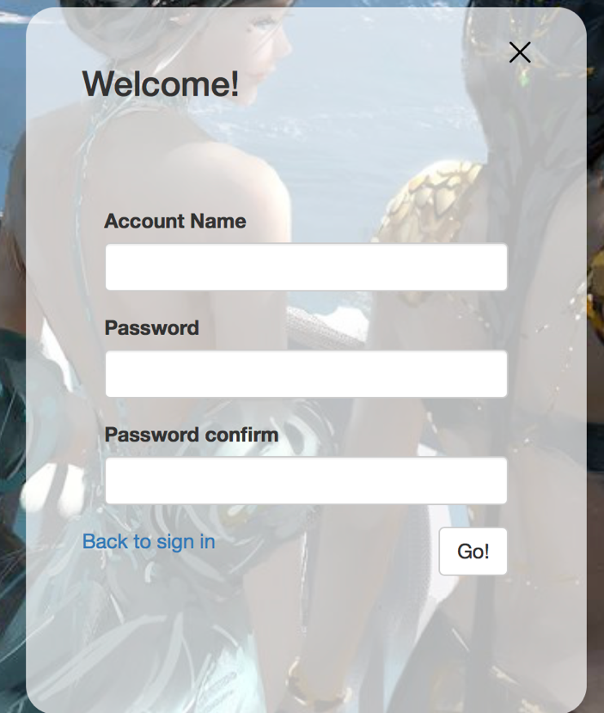

### **3.3 Sign in / Sign out**

* This function is relative to sign up part. Customers have their account, and for safety consider, websites must have a method to authentication the account customers provided. As a result, sign in and sign out part is necessary.

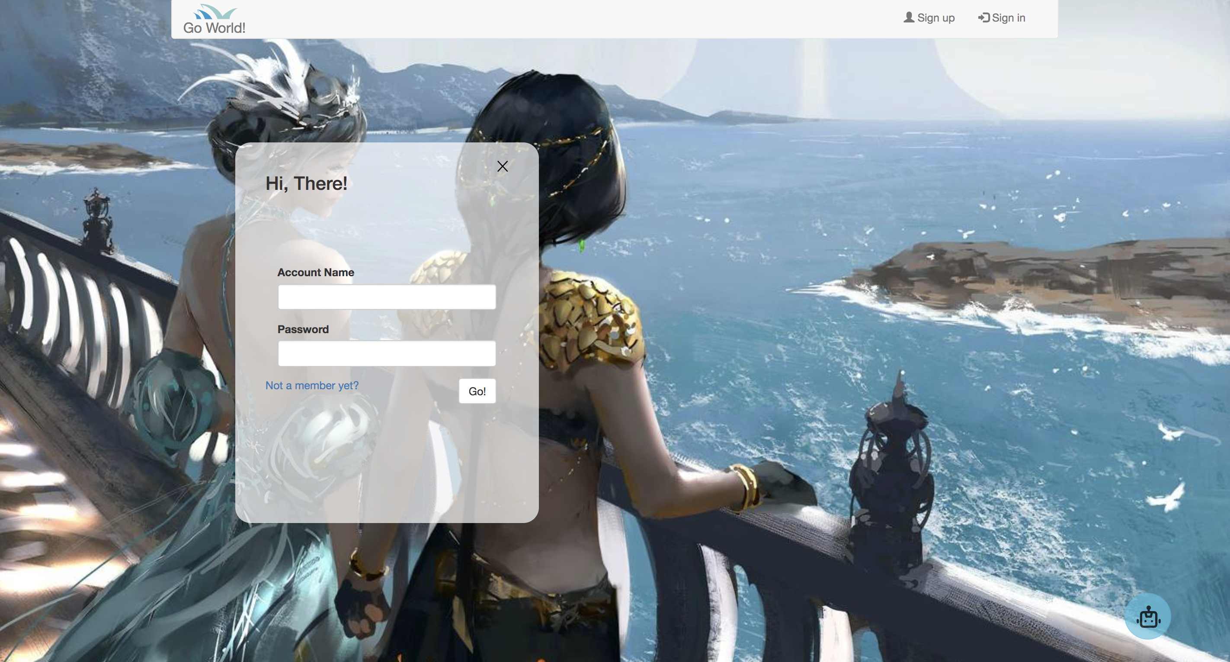

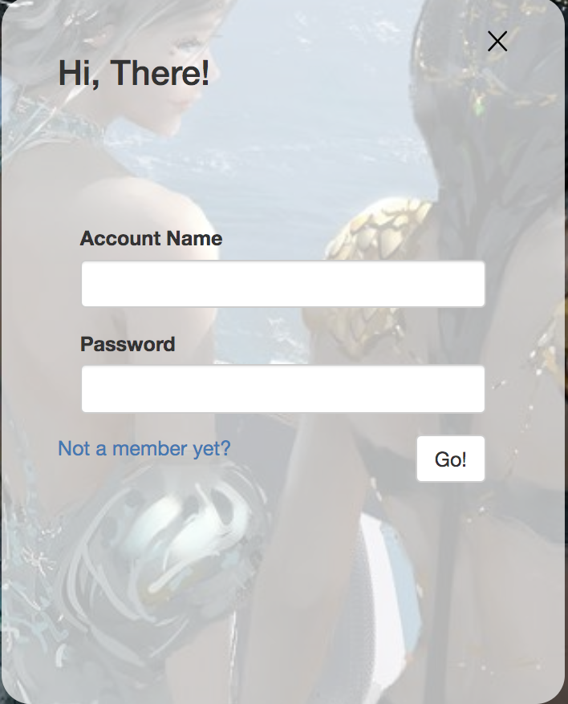 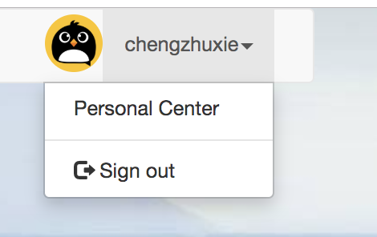

### **3.4 Search**

**General Search**

This search function is a normal search function that similar with any other accommodation

websites. It collects the customer input like, destination, number of people, arrive date and

departure date. Then return the result from database which is marched the users’ input.

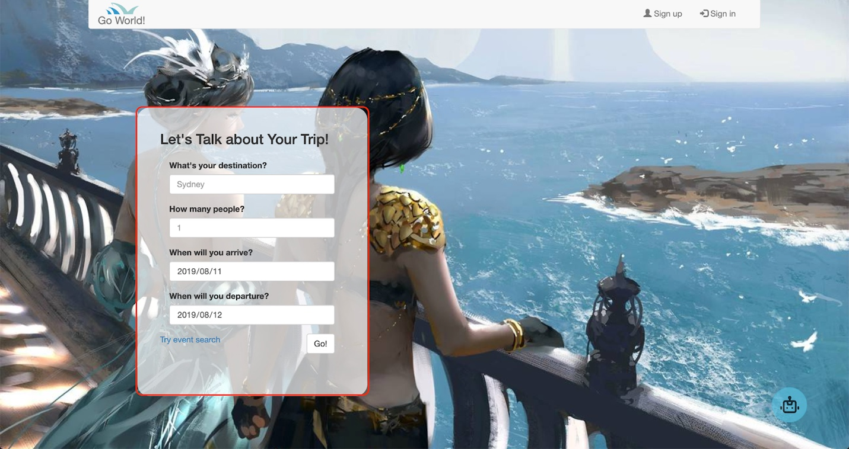

Output is like below: 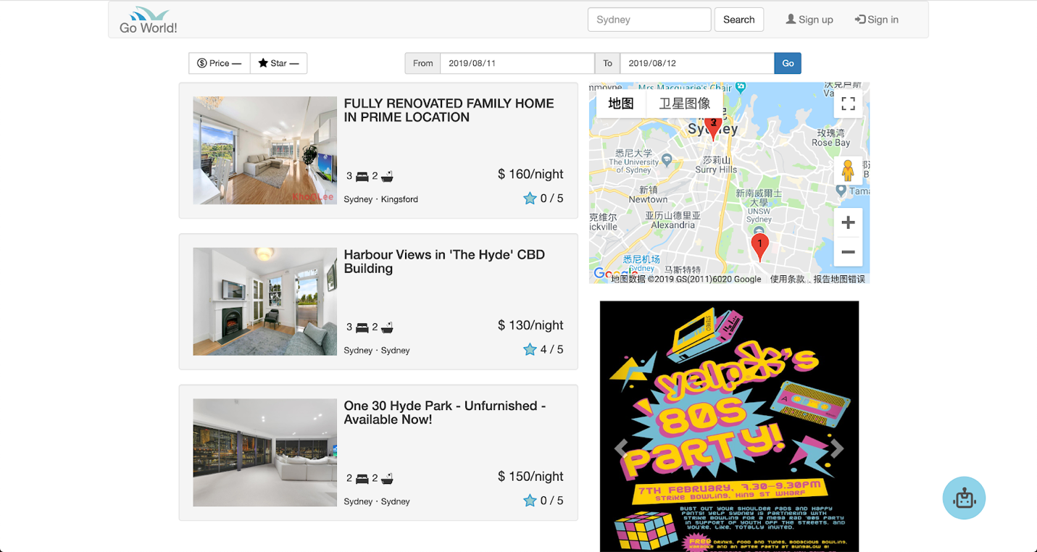

### **3.5 Booking an order & Order System**

* After *Sign in*, customer could browse property page via *search*. The result would show properties based on research information. Now customer can select a property and book it.

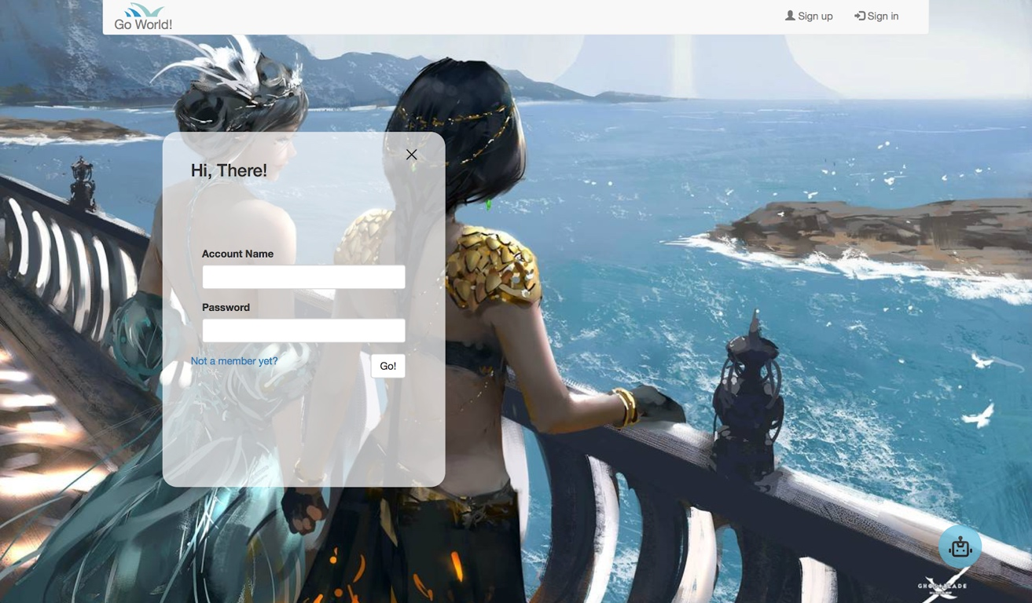

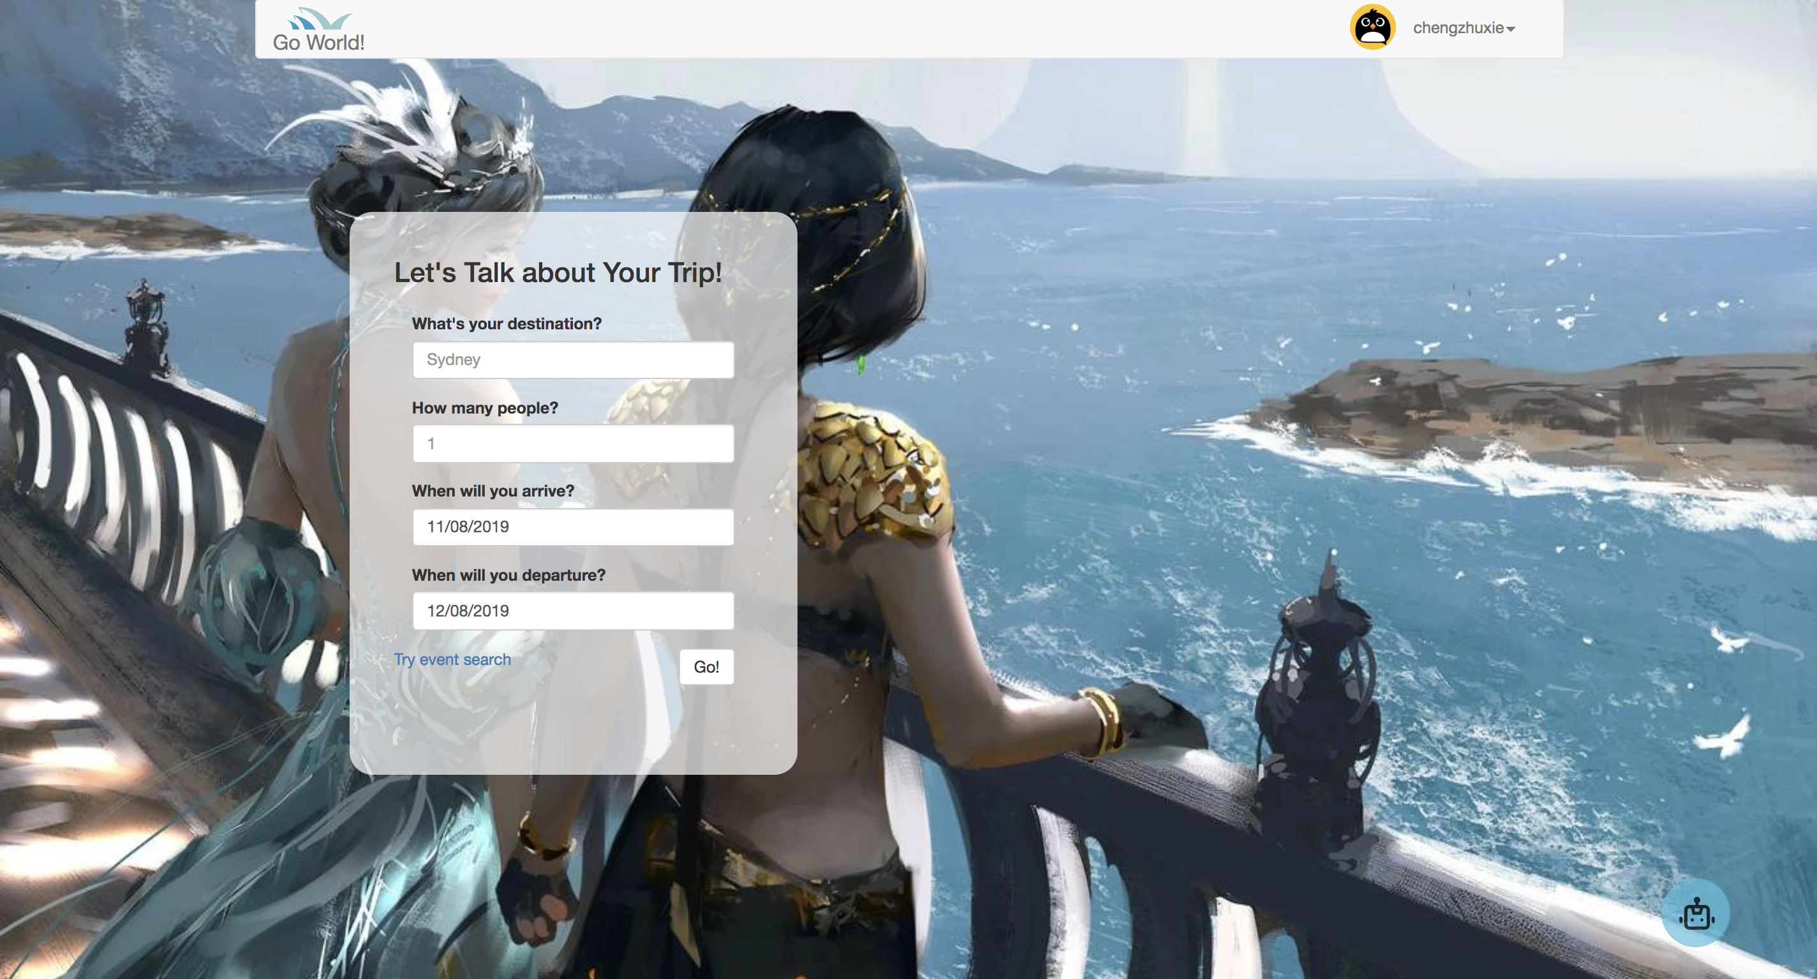

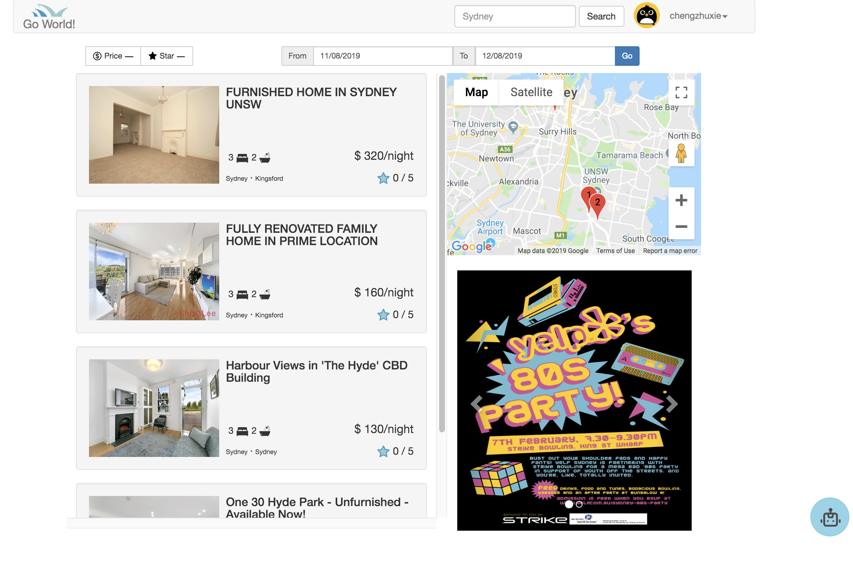

* Click button Booking Now, then fill *arrival time* and *departure time*, booking will be done if this time is available.

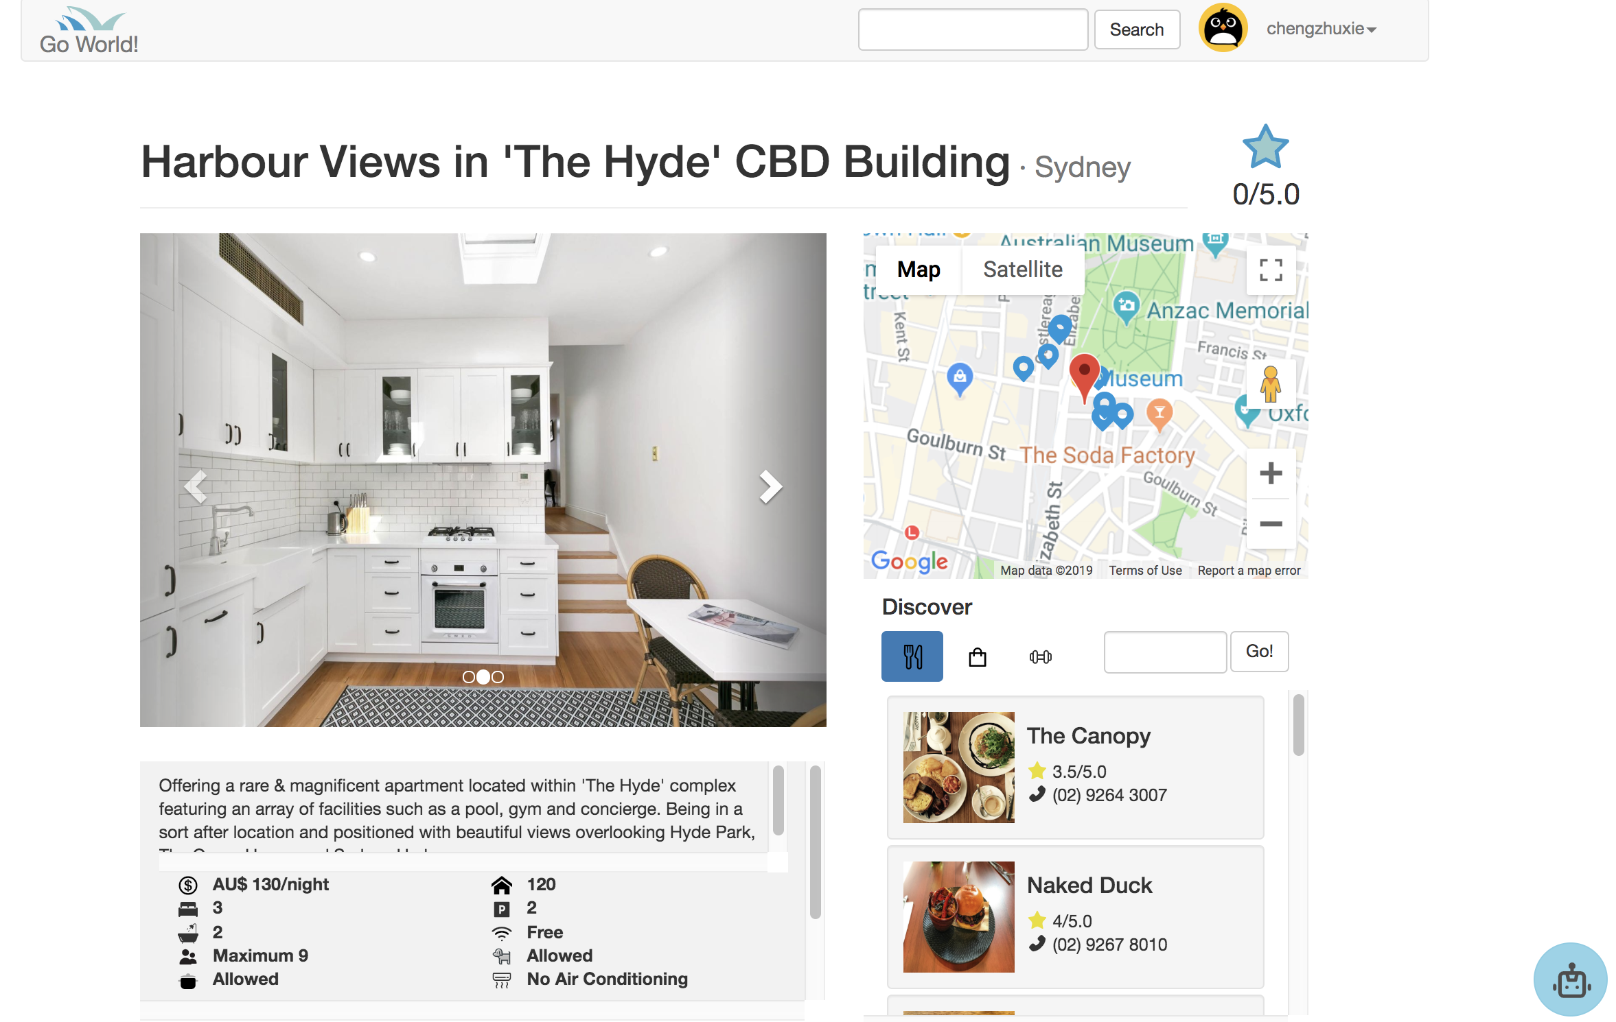



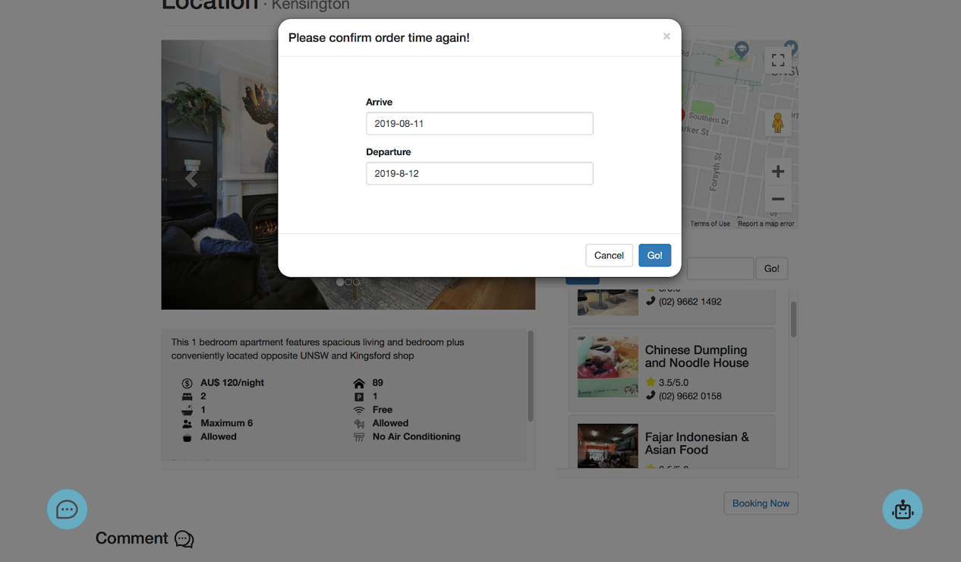

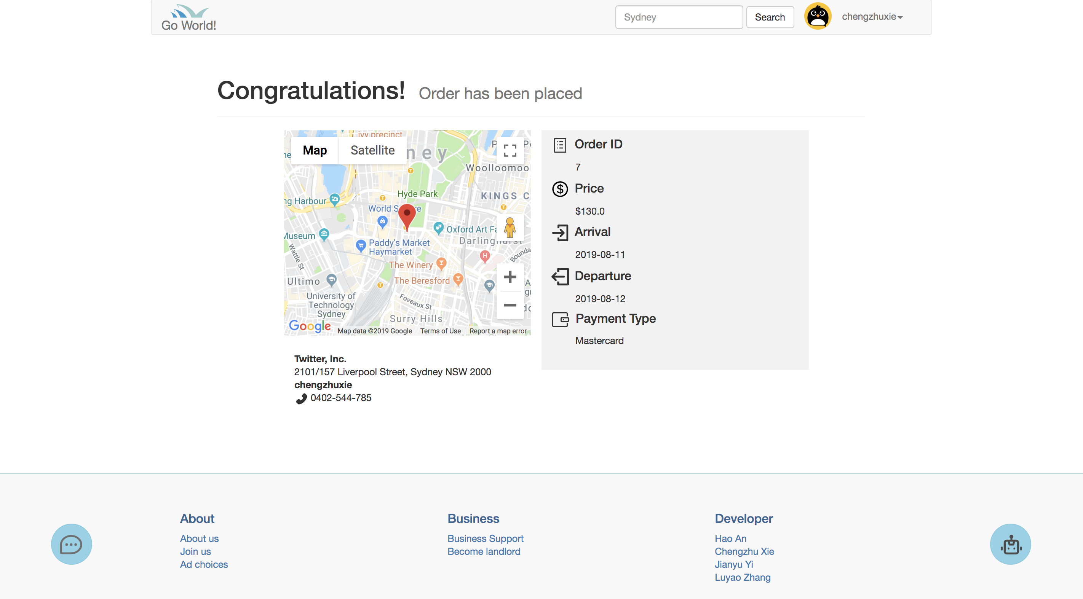

* Now, order information will show a*t Personal Centre.*

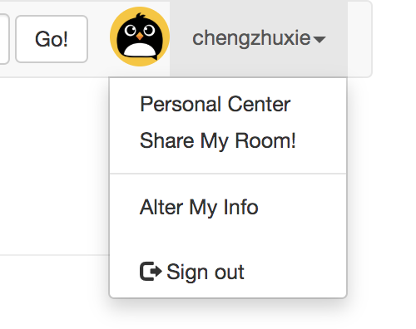

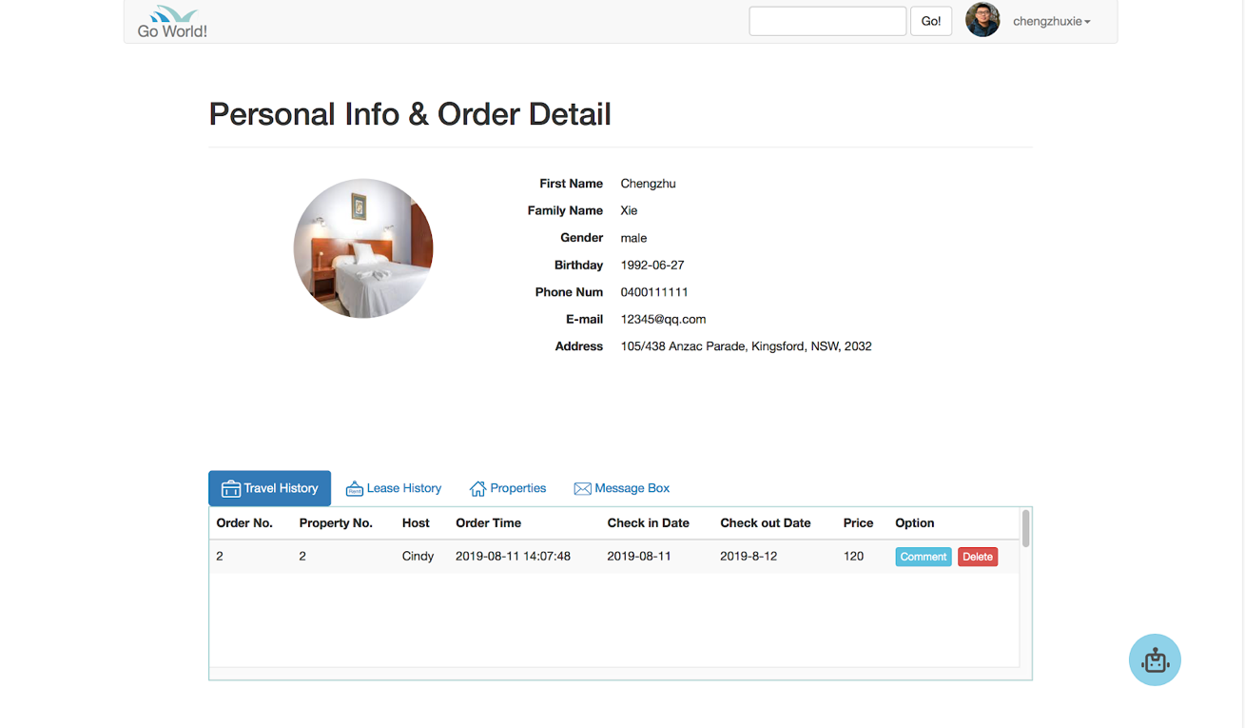

### **3.6 Write a Review**

* we have a review system for each property so that tenants can share their feelings. Also, new users who are interested in one specific property can see people’s feedback.  When you make a new booking, there is a trip order will be added to your trip order list. Users can see that on personal account page. You can see the following example, this user just booked a room and the order number is 8.

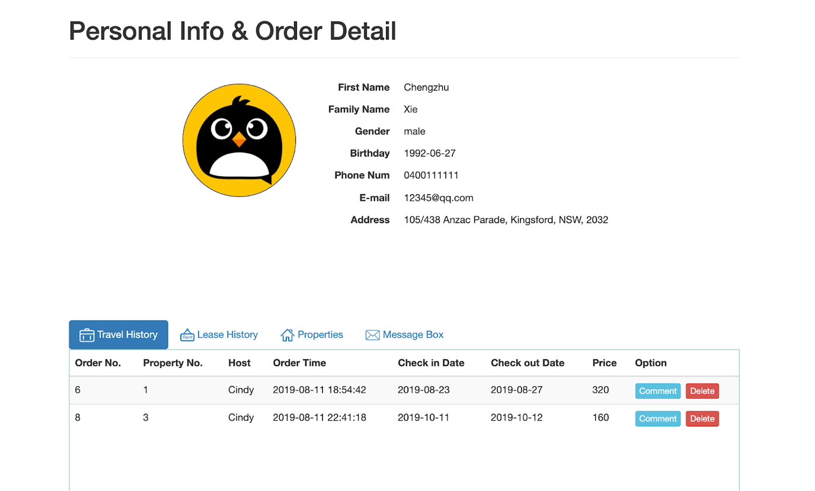

* Here is a “comment” button that you can give a comment to this property, the UI is showing as below. You can give a rating and text-style comment.

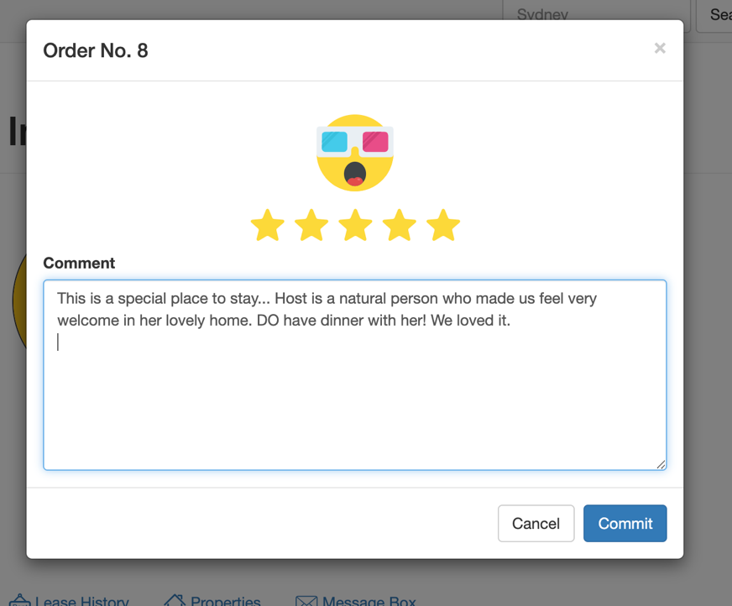

* Once you commit your review. The rating will be used for calculating the rating based on all rating from customers. This rating is used for sorting and listing search result.  The review will show under this property.

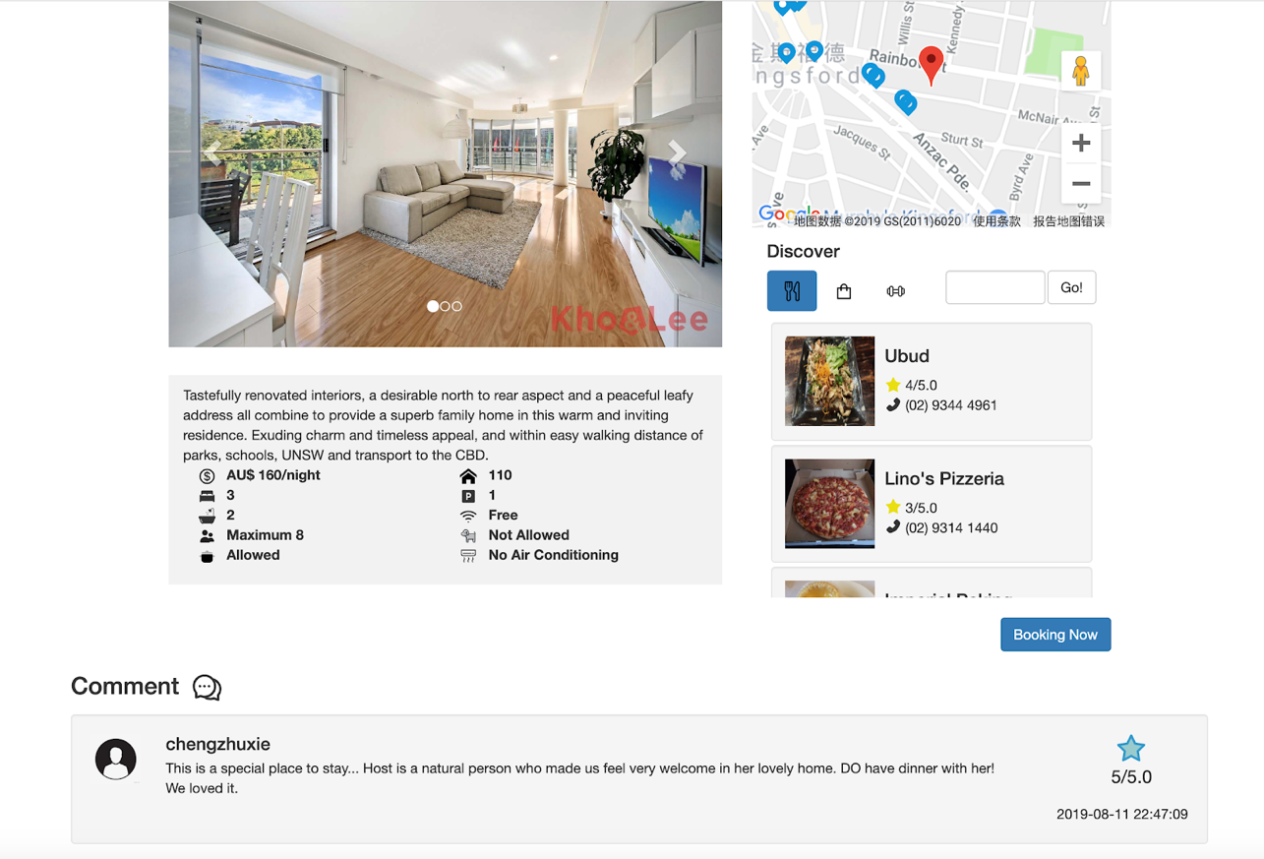

### **3.7 Relevant Recommendation  & Event Search**

* In this project, relevant recommendation called by event search. This means customers can use some events which can be search in yelp API as a keyword. If customers use event for search, if this event is in yelp event API, the server will return a property list around this event about 5000 meters range. and then mark the properties in map. If the input event is not in API database, the return will be the property list in customer location input.
* If user does not know any event , they can use just location to search the properties, or use the event given by homepage recommendation.
* This search is useful for the customers who want to join the event with no prepared before.
* For test this event search function, user can input:

1. Sydney & Yelp's '80s Yelper Party!
2. Sydney & You're invited to Yelp's FREE 10th Birthday Maritime Mixer
3. Sydney

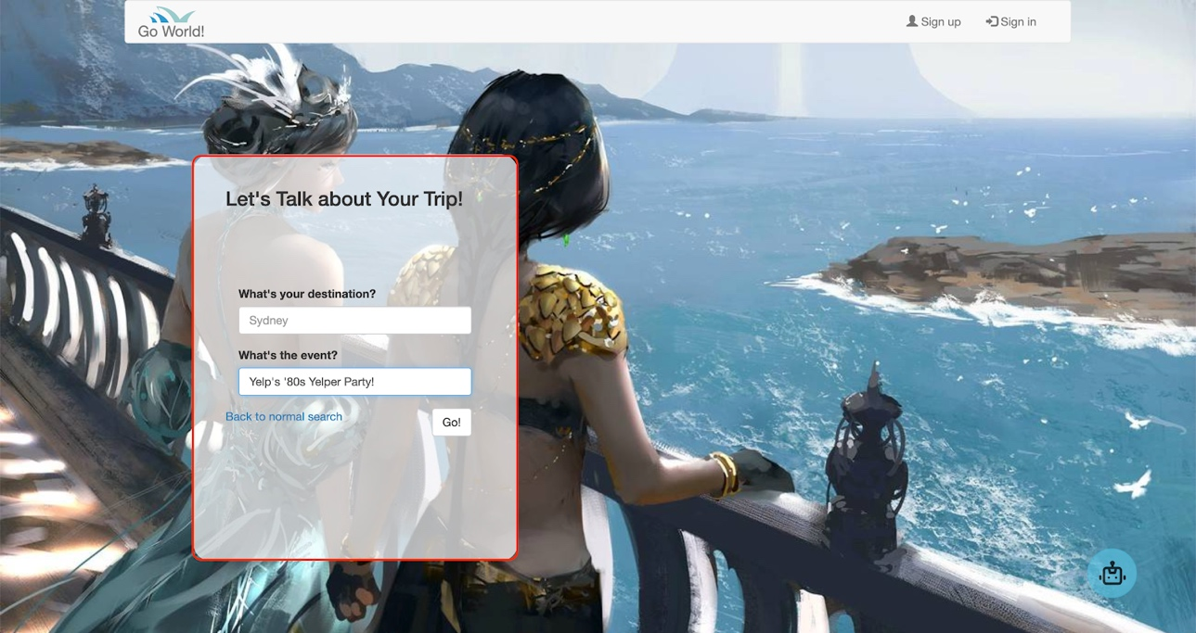

**Output is like below:** 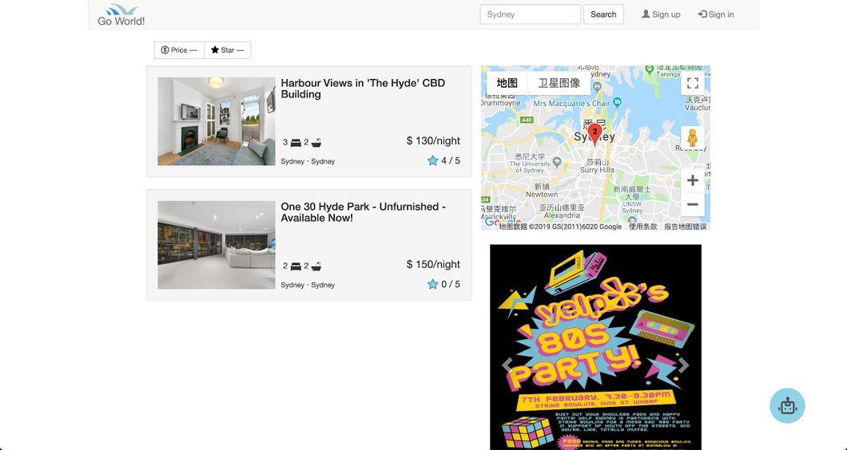

### **3.8 Message Box**

* we design this function to build a bridge between host and tenant. For an accommodation web portal, users need a smooth and quick way to communicate with other users, such as ask some banned activity and negotiate about accommodation. Users should be a legal registered member of our website. This message box is not a real-time communication, the entrance is located on property information page. When users use our search function and click into one property that they are interested in, the entrance of leaving message is on bottle left corner. Please see example below.

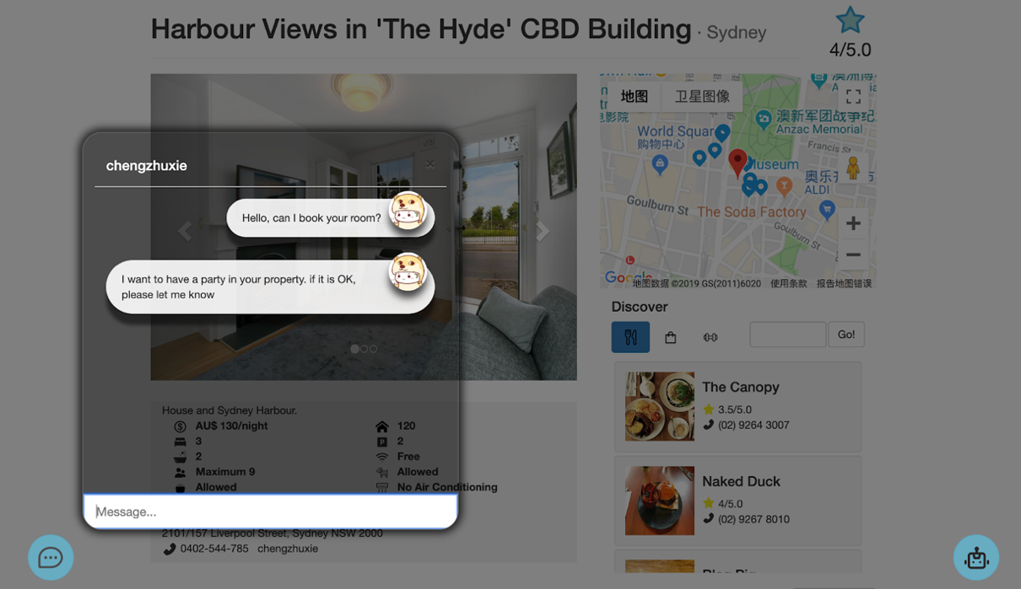

* Once you sent it, the messages will go to the receiver's message box. these messages can be seen when receiver goes to personal account page. There will be a red point to tell you that new message received.

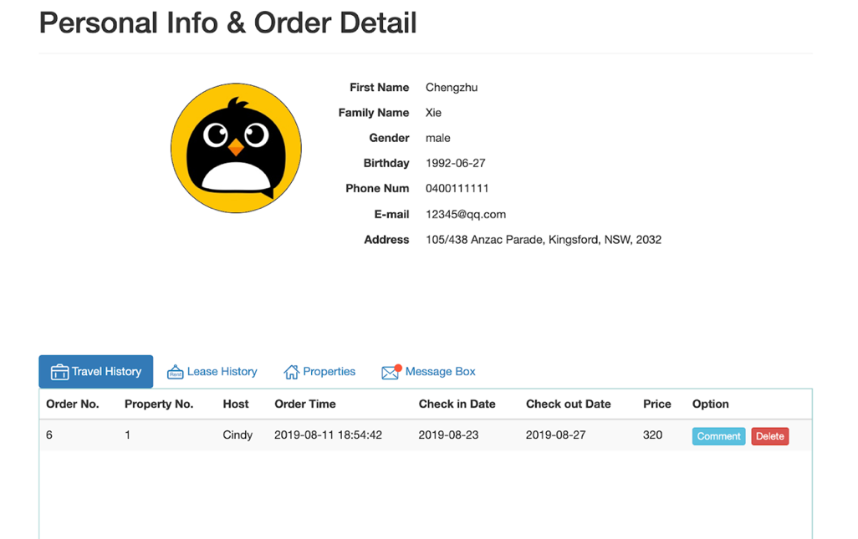

* The queue of message will sort with time so that the latest new message will be on the top. Click “Reply” button and reply the message. Also, user can review their chat history.

### **3.9 Chatbot**

Here we define this chatbot as a help assistant.  Users can use our chatbot in any webpage. The access button is located on the bottle right corner. When you type your query, chatbot will reply you with a guide and link (if there is a link). It can be very helpful for any potential user of our website, like if elders want to try our service, they can just ask our chatbot to access relevant webpage. Our users can efficiently find what they want. Since it is an additional feature, we are not expecting chatbot to be so smart and handle any query. There are six types of intents can be handled.

##### **basic greeting:**

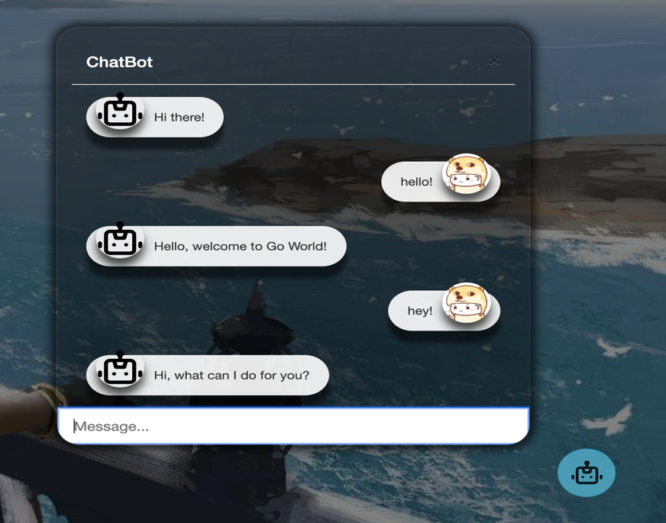

##### **Sign Up:**

If visitor wants to sign up on our website, he/she can query “sign up” or “I want to sign

up” some query like these, then chatbot will tell you where you can sign up.

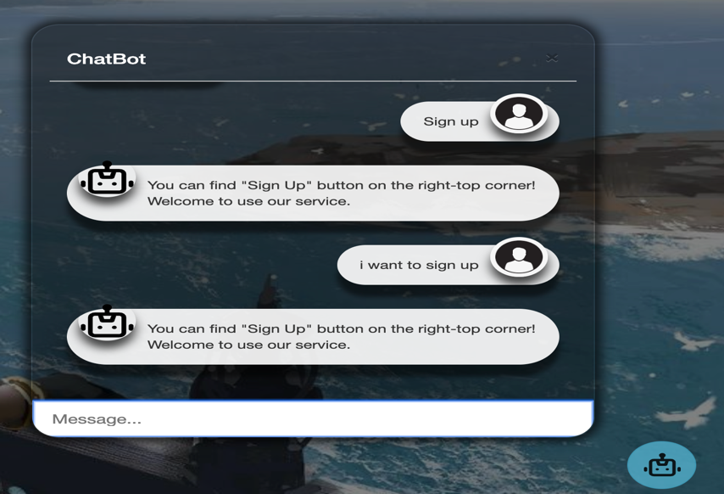

##### **General searching:**

You can input your demand for searching properties. Since this chatbot is machine-learning based chatbot, so in theory, you can ask is in your way. the query is similar to our searching function. you can query chatbot with destination, number of people, arrival date and how long you will stay. Here are some examples.

**Sample1:** I want to book a room in Sydney.

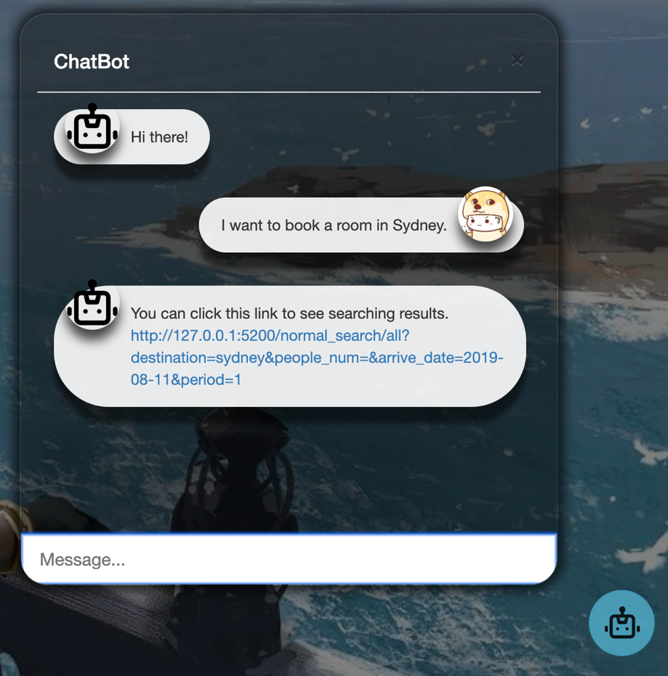    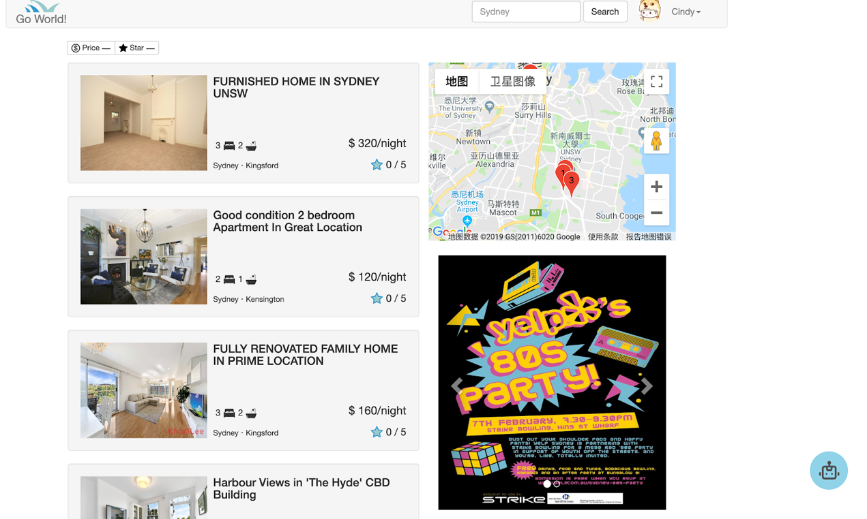

**Sample2:** Can I reserve a property in Newcastle from September 1 to September 3.

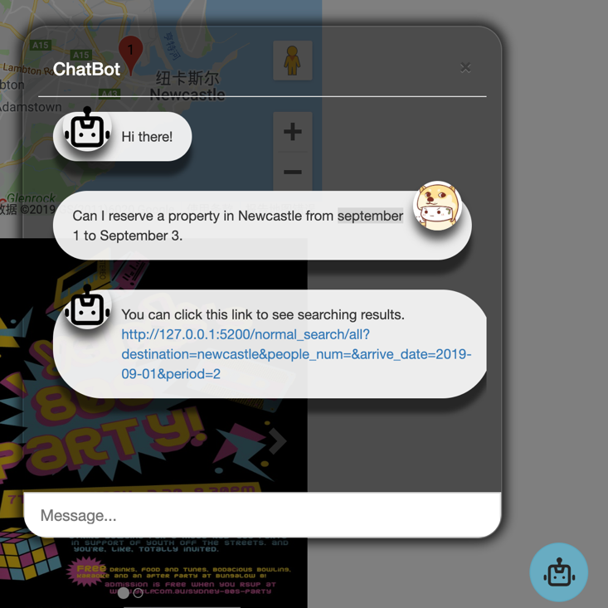  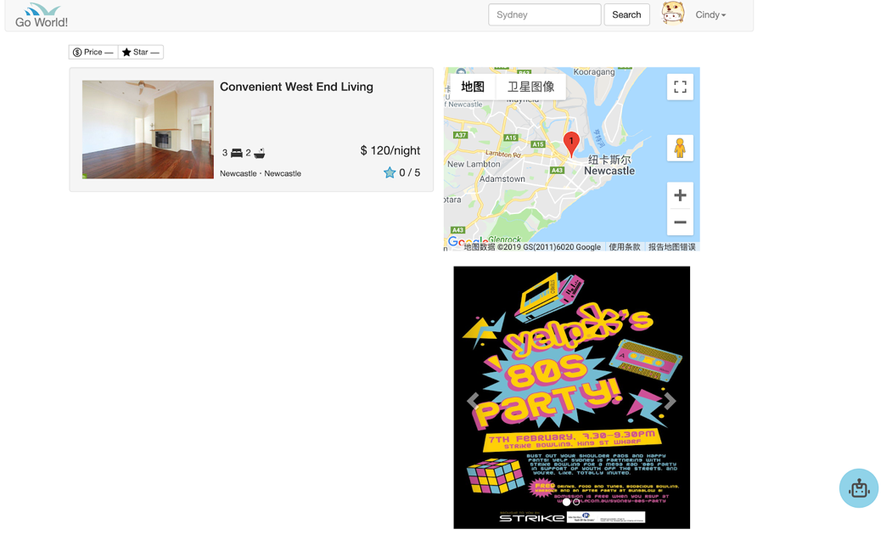

**Sample3:** I want to book a room in Sydney for 4 people. (if user does not provide an arrival date, the default date is “today”.)

**Sample4:** Reserve a room in Sydney on Sunday (the default of Sunday is next available Sunday).

##### **Access personal account**

We default users only can browse their own personal account. So, there will be two situations depend on user log in or not. You can see the example below. If you have logged in, you will get the link to redirect you to the expected page, otherwise, chatbot will guide you to log in.

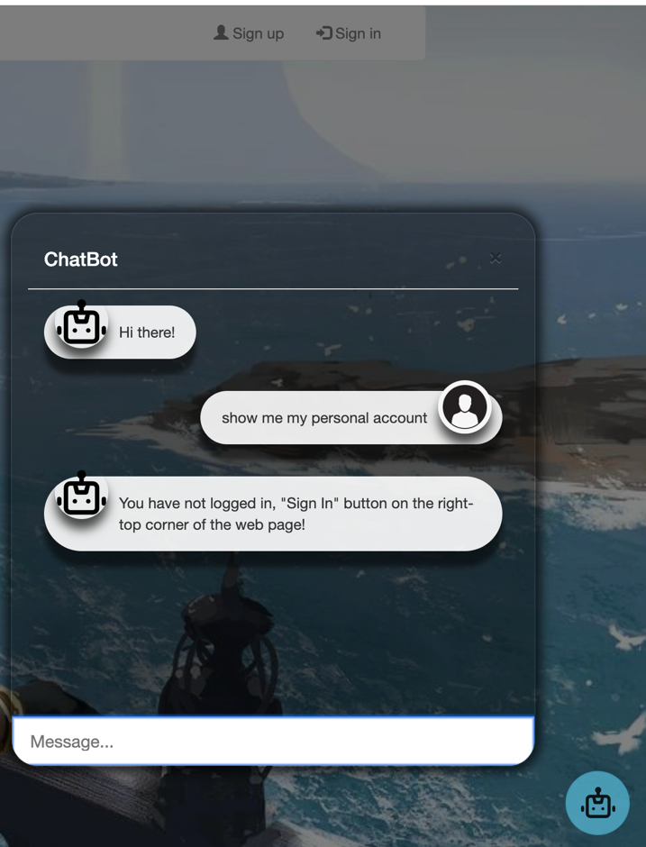  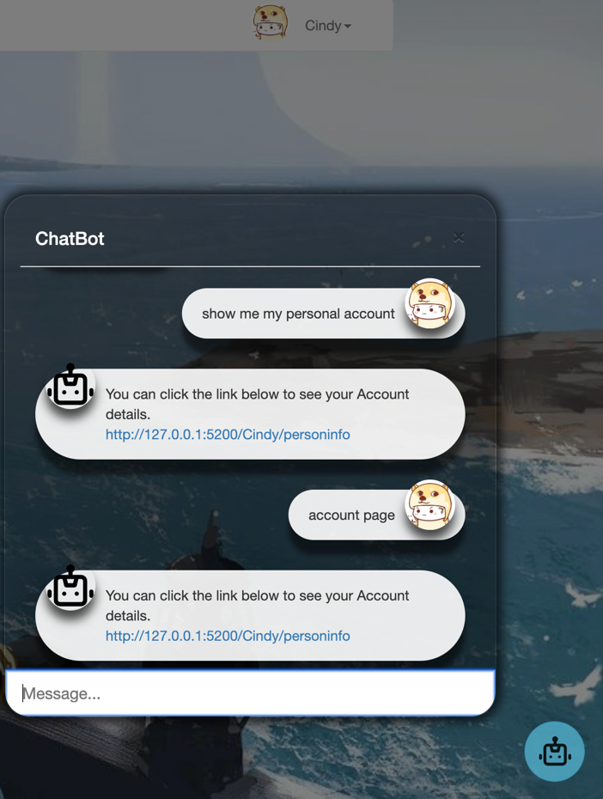

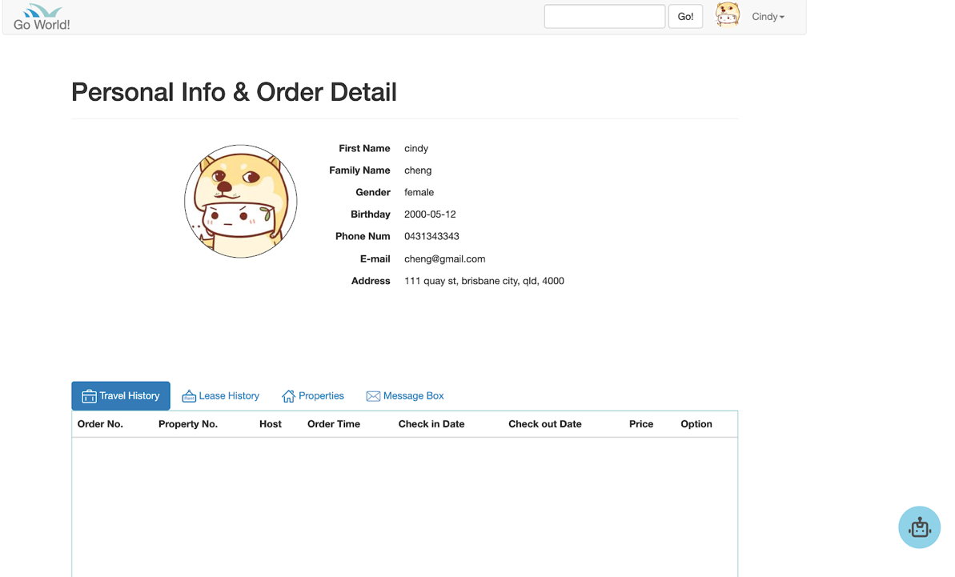

##### **Order related operation**

User need log in before query this. if not login, it will guide you to log in first. Since order detail is shown on personal account page, chatbot will provide a link and user can go to personal account page to see order details. (%%%%%%%) Our chatbot can distinguish users’ intent, such as show order list and cancel order. Different reply will be given.

##### **Query contact details about specific order**

The most common issue in accommodation rental is how to contact host or tenant. Here is a convenient helper for our users to check the contact details of specific order. User need to query with order number (can be seen in order history). Chatbot can realize your identity and provide the contact details of this order. Please see the following example.

Here user has a trip order with order number 7, user wants to contact the host of its order.

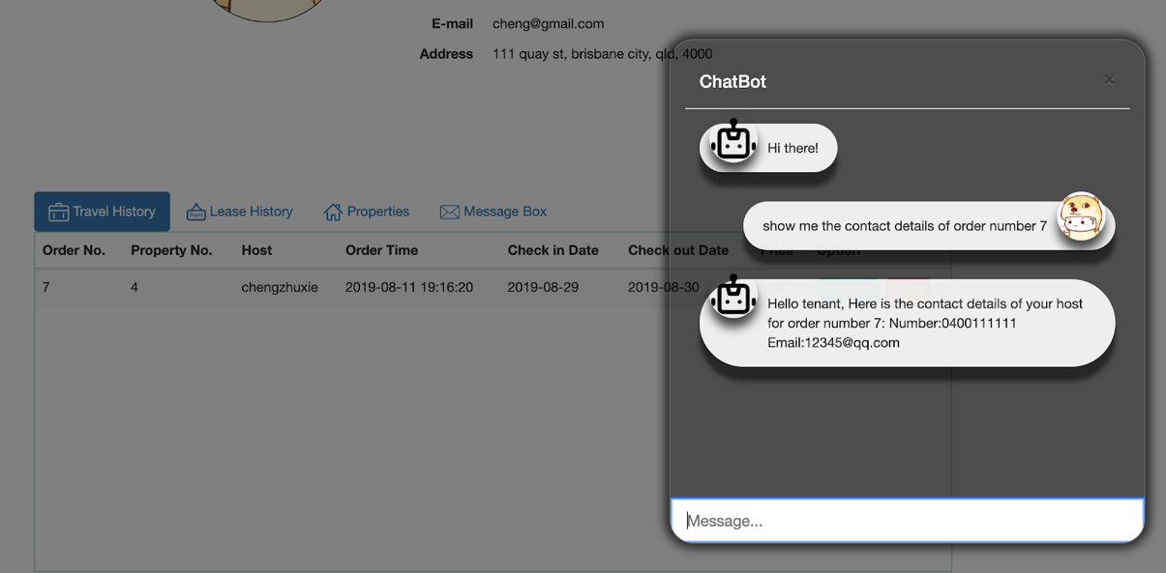

user has a lease order with order number 5, host wants to give the contact with tenant.

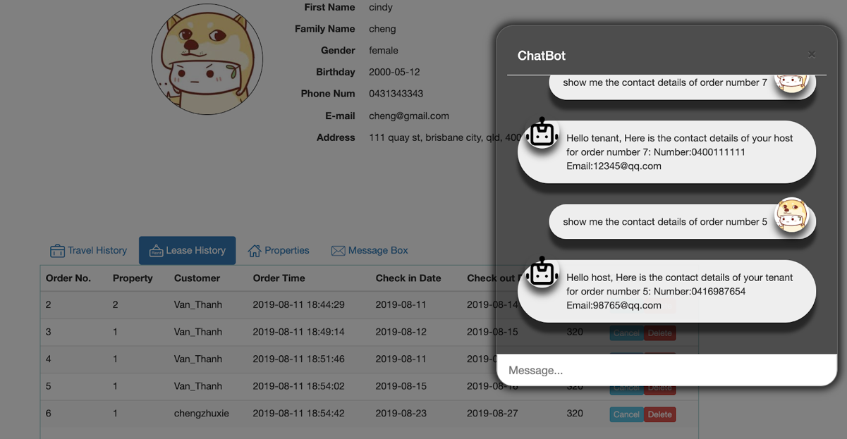

If user forget to provide order number, chatbot will ask user to query with order number.

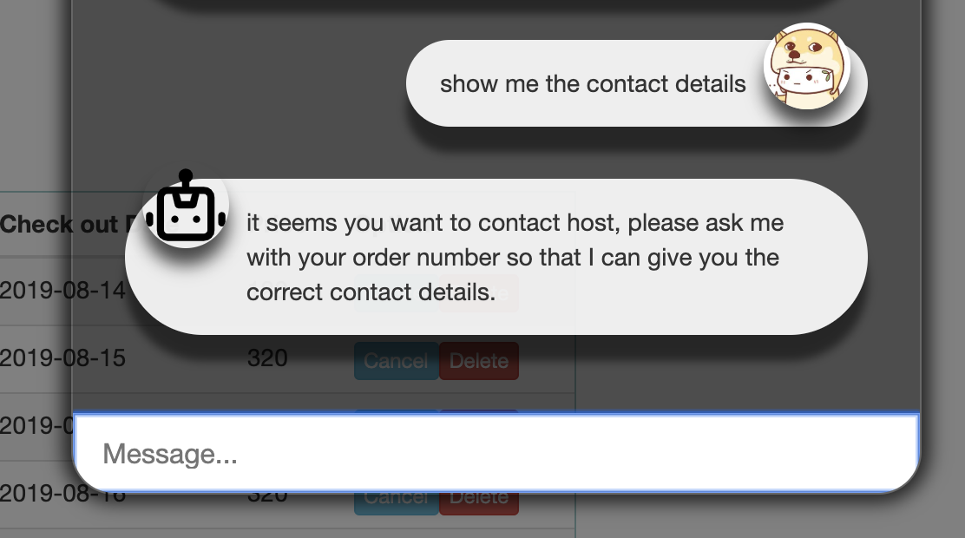

Also, if you ask an order not belong to you, chatbot will give you a proper reply.

## **4. Software Architecture**

|  |
| --- |
| Presentation (Python, HTML, CSS, JavaScript) |
| Business Layer (python) |
| Data Access Layer (RESTful API) |
| Data Storage (MongoDB) |
| Infrastructure Layer (Unix) |

**Python:**

All of us be familiar with python language. So the main body of this project will be built based on Python. Python is an interpreted, high-level, general-purpose programming language. Its language constructs and object-oriented approach helps programmers write clear, logical code for small and large-scale projects. It is mean that four of us be easily read and understand others code and integrate that. Most important point is that Python is dynamically typed and garbage-collected. it supports multiple programming paradigms. Also, Python allows programmers to define their own types using classes, which are most often used for object-oriented programming.

**HTML:**

Hypertext Markup Language is the standard markup language for documents designed to be displayed in a web browser. It can be assisted by technologies such as Cascading Style Sheets (CSS) and a scripting language such as JavaScript.

**CSS:**

Cascading Style Sheets is a style sheet language used for describing the presentation of a document written in a markup language like HTML. CSS is designed for presentation and content, including layout, colors,  and fonts. this separation can improve more flexibility and control in the specification of presentation characteristics, enable multiple web pages to share formatting by specifying the relevant CSS in a separate. CSS file and reduce complexity and repetition in the structural content. Beautiful is better.

**JavaScript:**

It is a high-level, interpreted programming language that conforms to the ECMAScript specification. JavaScript has curly-bracket syntax, dynamic typing, prototype-based object-orientation, and first-class function.

**MongoDB:**

All the data will be stored in MongoDB as JSON format like user name, password and picture.

## **5. Conclusion**

### **5.1 Challenge of Implementation & Solutions**

* The problems in this project, first, for event search, at the beginning is designed to return a list of properties that have the same keyword as event name. That means, in database, every property must have an attribute to save event keyword. This is not a very proper way to solve the problem. To make this problem more intelligent, the result of property list to return, is calculate by the distance to event place. Using the latitude and longitude of each property, and event latitude, longitude to compute the distance between the event and property. Then select the proper distance, like 5000 meters to get the result list.
* The websites often need to get some data from backend without refresh the page. For this part, websites should use AJAX to communicate with backend. AJAX is a method to exchange data with the server and update part of the web content without reloading the entire page.

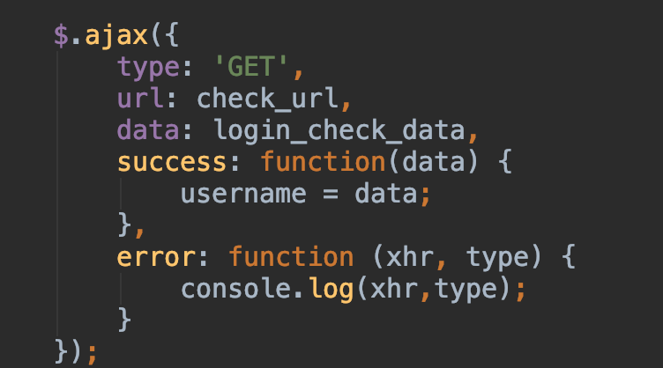

* For advanced the recommendation function, the inefficient way is saved the further data in database. Another method to deal the problem is, using the API from other web server. This project using YELP API to search restaurant, gym, shopping centre, event etc. YELP API has adequate data to implement this project. In python, if you want to get the API data, just use requests to get it.

## **6. Maintenance & Operation**

* **Security Level:**

In this project, we had use token-based security. When user logged in, back-end server will check if this user is a legal member of website. Then, back-end server send a token which generated by user account id. Once get this token, user can access the page or function which need authority. The advantage is that it is very easy to implement and correctly give the authority to member. The drawback is that if someone captures your token, he/she also can access our back-end server. Due to this, we will implement higher level security to protect our system and privacy of user.

* **Database architecture:**

Our portal uses MongoDB as database. The structure of each type of data is designed at the beginning. During the development of this project, we add and modify many times to meet our demand, such as for convenient of get all desired data for personal account, we need to store a great deal of data to customer collection for each customer. So, much redundant data exists in our database. For further work and maintenance, we are going to adjust the data structure and make it simpler and efficient so that extracting data from database can be fast.

* **Long response time:**

Currently, our front-end needs show a great many pictures. We stored pictures in MongoDB. When browser loads a page which contains many pictures, the loading time sometimes is a little long. This is because MongoDB has a poor performance on transmitting pictures. To simplify the structure of the project, we do not use other database to store images. In the future, we can use another highly efficient database to transmit and store images.

* **API for database:**

this project consider that if the system developing, it may has some other platforms like phone APP. To ensure the database can easily access, the API linked the database is necessary. This API just for processing the data from database. The operations like, create a new account, post property, delete property, book property etc. will implement via this API. In future, if the server growth, other platforms can use this API to get data.

## **7. References**

[1] Xplenty 2017,’The SQL vs NoSQL Difference: MySQL vs MongoDB ’.​*Medium,*​accessed 07 March 2019,

https://medium.com/xplenty-blog/the-sql-vs-nosql-difference-mysql-vs-mongodb-32c9980e67b2

[2] google

<https://zh.wikipedia.org/wiki/层叠样式表>

[3] google

<https://zh.wikipedia.org/wiki/HTML>

[4] <https://wit.ai/docs>

[5]<https://www.abs.gov.au/ausstats/abs@.nsf/products/961B6B53B87C130ACA2574030010BD05>

[6] <https://www.abs.gov.au/AUSSTATS/abs@.nsf/mf/8635.0>